**Install AWS CloudWatch Agent on an EC2 instance:-**

1. Create an IAM role and assign “[**CloudWatchAgentAdminPolicy**](https://us-east-1.console.aws.amazon.com/iam/home?region=ap-south-1#/policies/details/arn%3Aaws%3Aiam%3A%3Aaws%3Apolicy%2FCloudWatchAgentAdminPolicy)”.
2. Create an EC2 instance and assign an IAM role.
3. Install CloudWatch Agent on the EC2 server.
4. Create an IAM role and assign “[**CloudWatchAgentAdminPolicy**](https://us-east-1.console.aws.amazon.com/iam/home?region=ap-south-1#/policies/details/arn%3Aaws%3Aiam%3A%3Aaws%3Apolicy%2FCloudWatchAgentAdminPolicy)”.

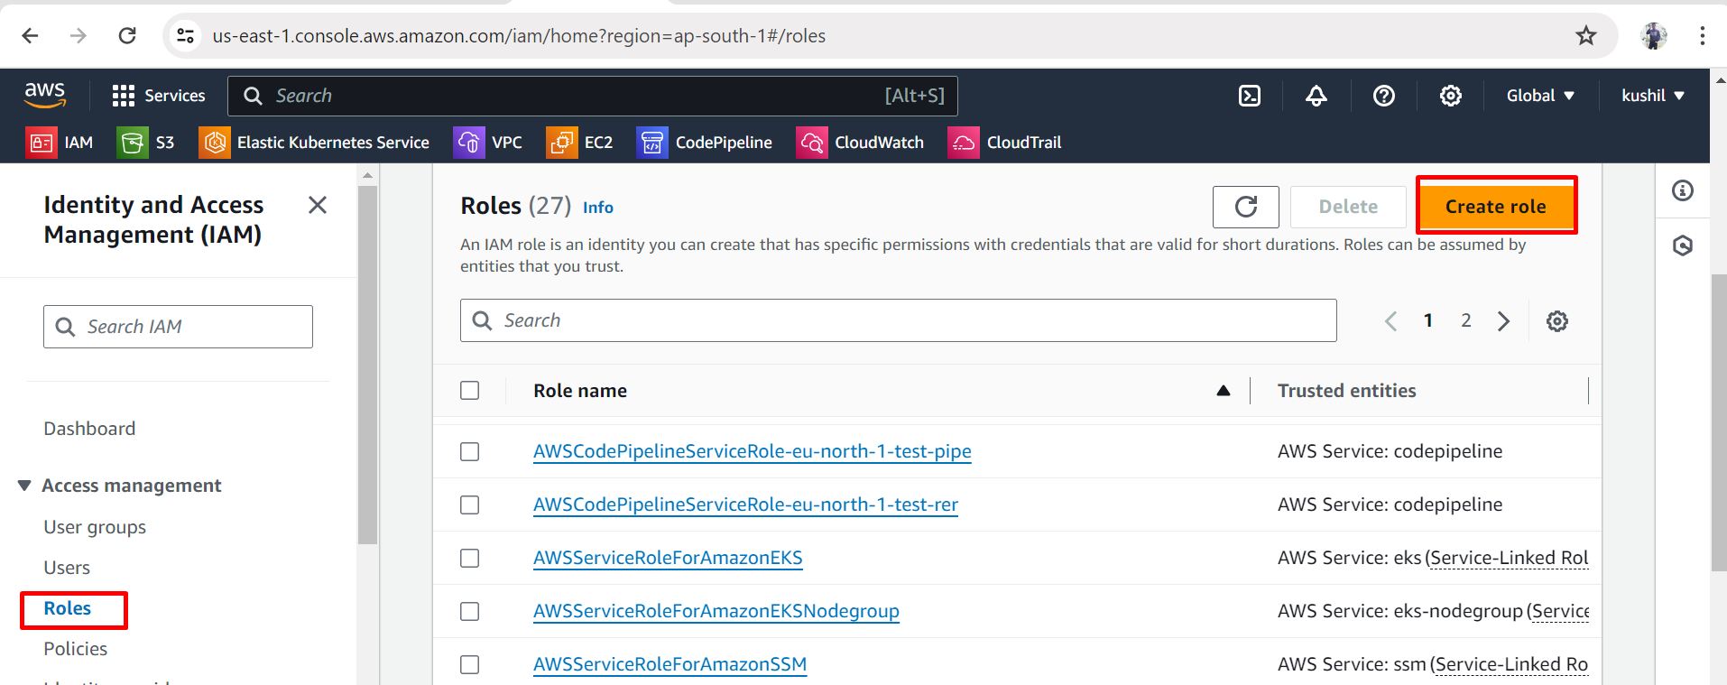

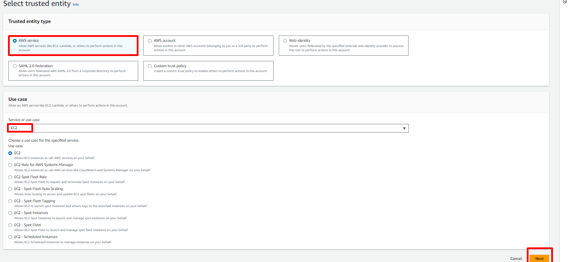

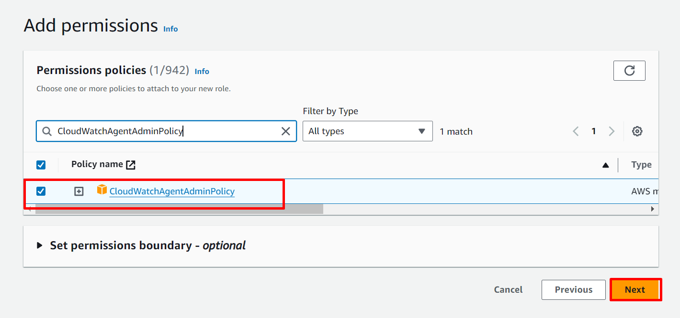

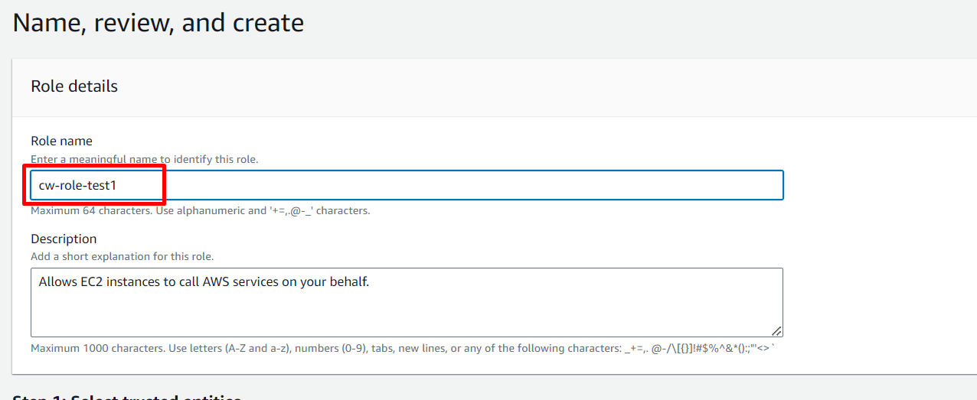

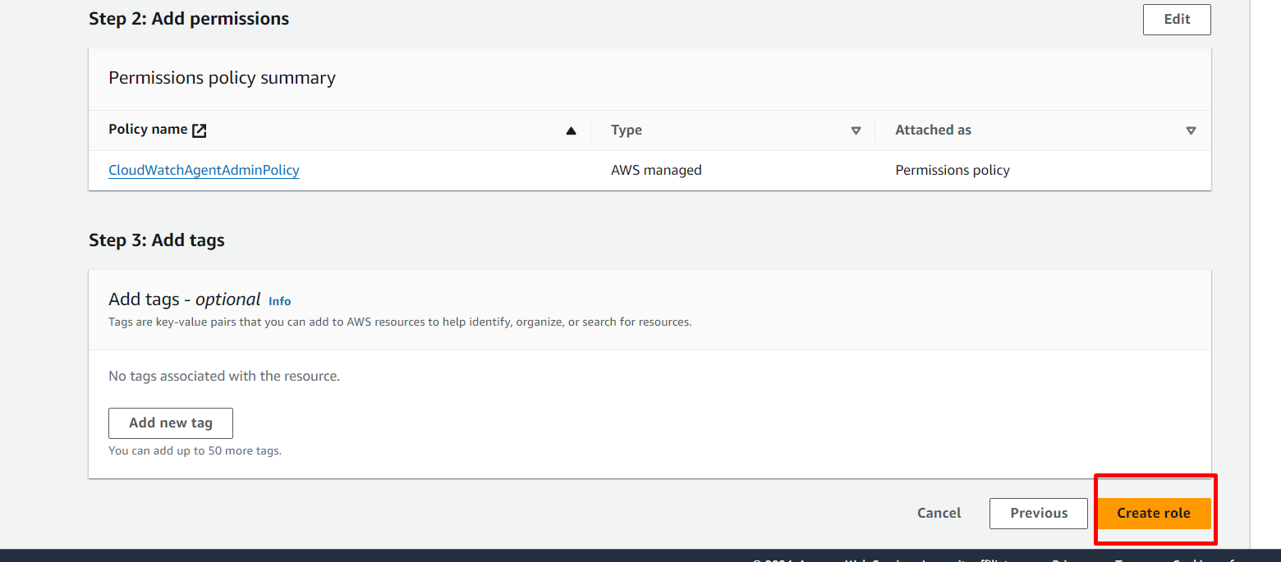

2. Create an EC2 instance and assign an IAM role.

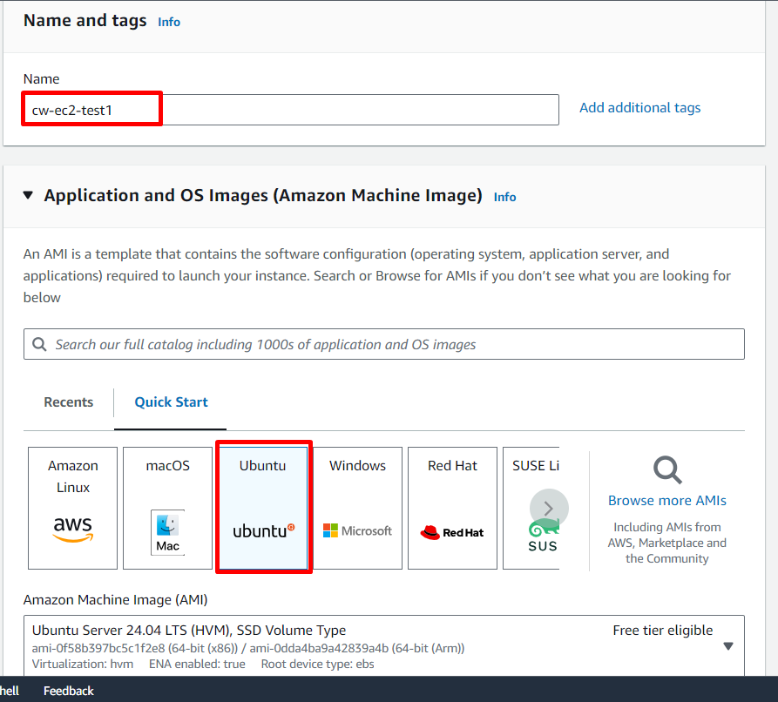

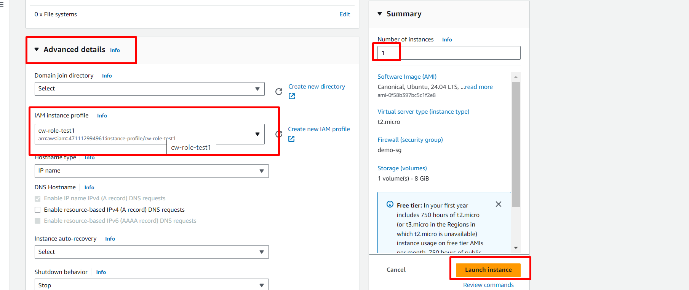

3. Install CloudWatch Agent on the EC2 server.

